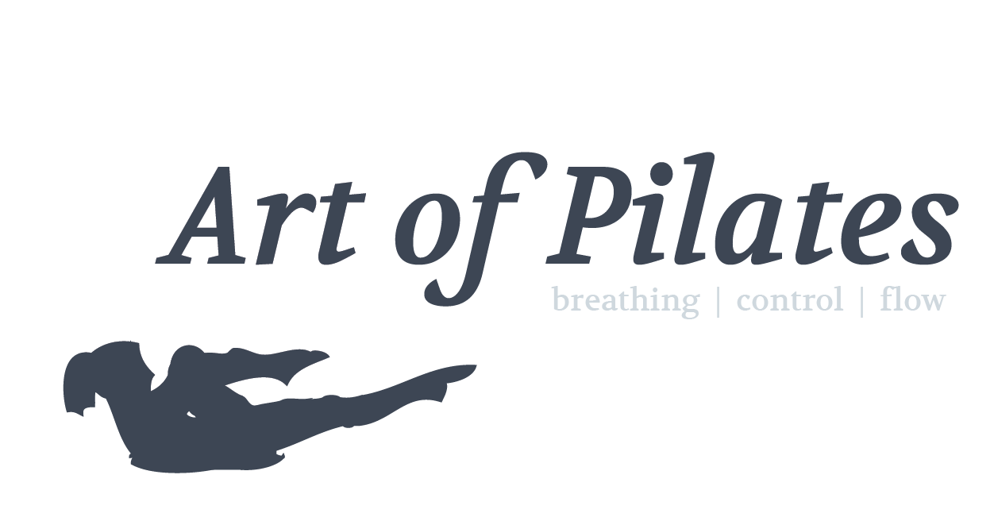
Physical health questionnaire

Please complete this questionnaire and send it by email to tracy@artofpilates.co.uk or print it out and bring with you to your first Pilates class.

Your contact details

Name
Email
Phone

ICE contact details

Please enter your In Case of Emergency (ICE) contact details below

Name
Phone

Physical health

Do you have any physical health problems? (Tick those that apply)

Back ❏
Blood pressure ❏
Breathing ❏
Diabetes ❏
Epilepsy ❏
Heart ❏
Joints ❏
Other ❏

Physical health cotd.

Are you currently taking any medications that could affect your ability to undertake physical activity? (Please circle)

Yes No

Do you know of any reason why you should not do physical activity? (Please circle)

Yes No

Terms and conditions

Art of Pilates accepts no liability for personal injury resulting from your participation in a class if your doctor has advised you against exercise, you fail to observe safety instructions or if the injury is caused by another class participant.

Do you accept our terms and conditions? (Please circle)

Yes No

Signature

Date

